Dear 2022 TU Marching Band Members,

We have an EXCITING year planned for the TUMB culminating in New York City! It all begins with BAND CAMP woohoo!! ☺ There are many details to know concerning band camp and the season. Below is information to help answer your questions and an explanation of all the forms and information needed to get the season started. The website [www.towsonbands.com](http://www.towsonbands.com) is where we compile the most complete information about the TUMB. We also use Google Drive to share all information for members, the link is here: [Members Folder](https://drive.google.com/drive/folders/1FatCJ3BLHdlQbEmILkxbIU7nJcpoCbJY?usp=sharing).

As a band member, you should join our Towson University Marching Band Facebook group - <https://www.facebook.com/groups/tumbcurrentmembers/about/> As needed, the marching band office phone is 410.704.5485 and general email is [tubands@towson.edu](mailto:tubands@towson.edu). We do have a Facebook group for parents and family - <https://www.facebook.com/groups/tumbfamilyandfriends/about/> In addition, all attendance communication should be directed to [bandattendance@towson.edu](mailto:bandattendance@towson.edu)

After this introduction, follow the links under “Forms and Information” below for everything you need to know about joining the TUMB and band camp. Enjoy your last few days of summer and get psyched for marching band!

With Musical Enthusiasm☺,

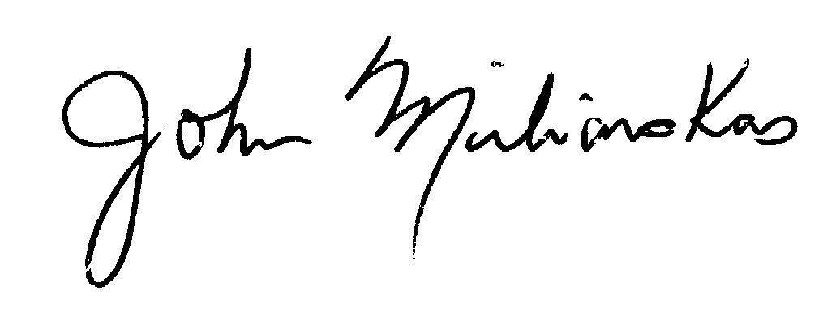

John Miliauskas

Director

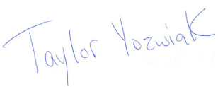

Taylor Yozwiak

Assistant Director

Director of Marching Percussion

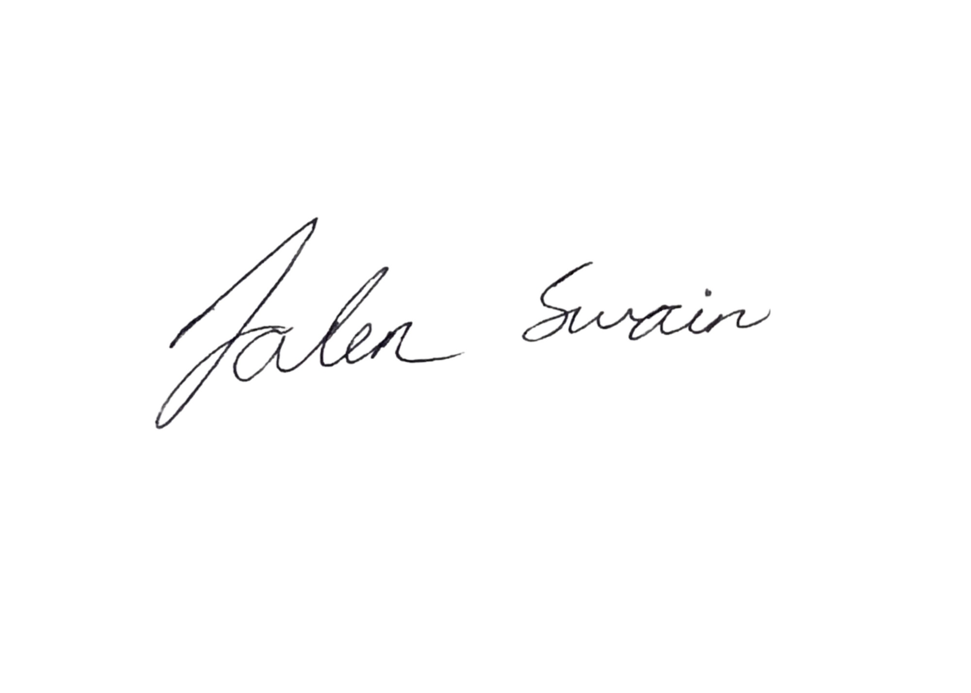

Jalen Swain

Administrative Assistant

Color Guard Director

# Band Camp Move In Date

Friday, August 19th – Marching band members who live in on-campus housing move into their rooms, and band camp begins for everyone!

# When you arrive on campus on Friday, August 19th

**1) Students living on campus** - If you haven’t already gone through band camp registration and uniform fitting during the summer, please check in to band camp in the Center for the Arts from **10am-11:30am**. Early Arrival Parking Permit is in the [Members Folder](https://drive.google.com/drive/folders/1FatCJ3BLHdlQbEmILkxbIU7nJcpoCbJY?usp=sharing). You can move into your residence hall as early as **9:00am**, or as late as **3pm**.See below for parking information.

**2) Students living off campus** - If you haven’t already gone through band camp registration and uniform fitting during the summer, please check in to band camp in the Center for the Arts from **1pm-2:30pm**. Early Arrival Parking Permit is in the [Members Folder](https://drive.google.com/drive/folders/1FatCJ3BLHdlQbEmILkxbIU7nJcpoCbJY?usp=sharing). See below for parking information.

**3)** Eat on your own for lunch and dinner before rehearsal

**4)** Everyone should report to the Kaplan Concert Hall (3rd Floor Lobby), in the Center for the Arts, for our “Welcome to Band Camp” session & rehearsal. Attendance starts at **5:15pm** and the festivities begin at **5:30pm**!

*Please allow approximately 45-60 minutes for Band Camp Check-In. For further details, see the 2022 TUMB Band Camp Schedule. Please don’t wait until the last minute to check into band camp! Come early!*

**Early Arrival Parking Permit -** *You should have received a parking permit to use while moving in to the residence halls, this is also one at this link:* [*Early Arrival Parking Permit*](https://drive.google.com/file/d/1-4NRh6gWerN5vF3qzM7I3k8kpTIOLETq/view?usp=sharing)

**Forms and Information**

In these Google folders you will find the following information to read through:

* [Band Camp Folder](https://drive.google.com/drive/folders/1LpDRnrHurX0C4RMKg9Qg432Ybpm24Uhw?usp=sharing)
  1. [Band Camp Schedule](https://docs.google.com/document/d/1OLJe0S5jqlcwrUle_hG0p2qQTDBv4j5x4kI6PnR3urQ/edit?usp=sharing) - *This gives a time framework for our band camp week. There will be unforeseen adjustments as we go along, please be patient!*
  2. [Band Camp Newsletter](https://docs.google.com/document/d/1-13VkglST0JxZC5i7k0SlpY6DEVFrCT3mda_wws_SoM/edit?usp=sharing)
  3. [Early Arrival Parking Permit](https://drive.google.com/file/d/1-4NRh6gWerN5vF3qzM7I3k8kpTIOLETq/view?usp=sharing)- *Follow directions and display during move-in*
* [Band Camp Forms to Fill Out](https://drive.google.com/drive/folders/13CboFEtAG5A8FTjCnKDbMI9z0c1iglYw?usp=sharing) folder
  1. [Recorded Sound & Image Release](https://docs.google.com/document/d/1aKBdvG2KBVH1yO7wDB-cbU4R9mG7xyZphcnmJtyv_PA/edit?usp=sharing) - *This allows us to make you a star!*
  2. [Liability Waiver for Travel](https://docs.google.com/document/d/1aKBdvG2KBVH1yO7wDB-cbU4R9mG7xyZphcnmJtyv_PA/edit?usp=sharing%5C) - *A standard form required by the university*
  3. [Handbook, TUMB](https://docs.google.com/document/d/1STLtgLrxwSbLT1eYP0DXRD5oiGnYJV9adCSUoe8pXdA/edit?usp=sharing) - *This technically isn’t a form, but it must be read before the Membership Agreement is signed. This handbook, along with the schedule on the website, serves as the course syllabus.*
  4. [Membership Agreement](https://docs.google.com/document/d/16eyGkKlvEhPlTtDH4RbUy7mFDDvZqdnlTHQ_wmbem48/edit?usp=sharing) - *By joining the TUMB, you are committing to a university marching band, but more importantly to all the other students in the band. This agreement commits you to fulfilling your responsibilities as outlined in the handbook.*

**Band Camp and Freshman Orientation**

Freshman will have academic meetings and other orientation activities on Friday, August 26th, Saturday, August 27th, and Sunday, August 28th. We have collaborated with the orientation people for when students should be at orientation, and when they should attend marching band rehearsal. The [Band Camp Schedule](https://docs.google.com/document/d/1OLJe0S5jqlcwrUle_hG0p2qQTDBv4j5x4kI6PnR3urQ/edit?usp=sharing) has all necessary information. The only additional exception is the Honors College Orientation in the morning of Thursday, August 25th. Those marching band/honors college students should attend that orientation session.

**Water for Rehearsals**

Considering the pandemic, it would be hard for us to fill up 5 gallon jugs of water for group sharing during band camp and keep it safe. The water fountains are still turned off on campus, but the water filling stations are working. Students will need to bring their own water for each rehearsal block. We suggest investing in a 1 gallon jug such as this [Igloo](https://www.walmart.com/ip/Igloo-1-Gallon-Sports-Beverage-Jug-with-Hooks-Red/925167316?wmlspartner=wlpa&selectedSellerId=0&wl13=2551&adid=22222222420449455996&wmlspartner=wmtlabs&wl0=&wl1=g&wl2=c&wl3=501107745824&wl4=pla-293946777986&wl5=9006729&wl6=&wl7=&wl8=&wl9=pla&wl10=8175035&wl11=local&wl12=925167316&wl13=2551&veh=sem_LIA&gclid=CjwKCAjwx8iIBhBwEiwA2quaqxVQNESqlEICKV8YCEpkdzDStBfVOwhYWoRX_p6ZSpNBHg1_FZ6v9BoCGOsQAvD_BwE&gclsrc=aw.ds), or this [Coleman](https://www.amazon.com/Coleman-3000000739-Beverage-Cooler/dp/B00363V3LI/ref=sr_1_8?dchild=1&keywords=water+jug&qid=1628194712&sr=8-8). Of course, please put your name on your water jug.

**Khaki Shorts or Pants**

We will use a “casual uniform” for more informal performances starting with convocation during band camp. We will provide the shirt, but students should wear khaki pants or shorts. This is also our pep band “uniform” for the winter/spring. An idea - some students have shopped at thrift stores to get their khaki’s.

**Attendance**

All attendance communication should be directed to [bandattendance@towson.edu](mailto:bandattendance@towson.edu). During the semester, when you arrive at rehearsal, the UDB app will automatically check you in using GPS associated with the app on your phone.

**Band Camp Meals**

We will be eating in Glen Dining Hall. All TUMB students will need to bring their TU One Cards every day as your band camp meals are pre-programmed on your One Cards. The TUMB provides meals listed on the schedule during band camp until meal plans become active for students living on campus. Breakfast is provided by our service sorority, Tau Beta Sigma, and lunch and dinner will be in the dining hall.

**Overnight Trip**

Typically, we embark on an overnight trip every fall (Saturday to Sunday). When we do, we have “5 Star Accomodations” for the trip - on a gym floor in a high school! :-) ...This year because of the pandemic, we are hoping to stay overnight in a hotel near New York City the night before the Veteran’s Day Parade. This is dependent on fundraising. Our “Plan B” is to leave super early on the 11th and travel right to the parade. Stay tuned!

**Band Handbook**

The TU Marching Band Handbook helps guide everyone in meeting expectations. Because marching band is a “team” activity that does not have a bench to replace absent members, every member’s presence and positive contribution is very important at all times. The handbook states the expectations of attendance, conduct, and other areas of member responsibility. Prior to band camp, all members must read this handbook, which can be found in the [Members Folder](https://drive.google.com/drive/folders/1FatCJ3BLHdlQbEmILkxbIU7nJcpoCbJY?usp=sharing) on Google Drive .

# Member Agreement Form

In conjunction with the handbook, all members must sign the Member Agreement Form. Your signature on this form indicates that you understand the expectations of all members of the band. This form can be found in the [Members Folder](https://drive.google.com/drive/folders/1FatCJ3BLHdlQbEmILkxbIU7nJcpoCbJY?usp=sharing) along with the Recorded Sound & Image Release and the Liability Waiver for Travel.

**Remember To Bring For Band Camp…**

* Instrument (We provide all percussion, tenor saxes, mellophones, trombones, baritones, & sousaphones)
* Sneakers with great support! *Vans and “chucks” are sneakers, but do not offer much support. It’s recommended that you use a cross trainer or running type of sneaker.*
* Clothes conducive for marching and the summer weather
* Sunscreen
* A charged phone and possibly a portable charger such as this one - [Anker Portable Charger](https://www.amazon.com/Anker-Ultra-Compact-High-Speed-VoltageBoost-Technology/dp/B07QXV6N1B/ref=sr_1_2_sspa?crid=36HUKJFIPOW0O&keywords=portable%2Bcharger&qid=1660231166&refinements=p_72%3A2491149011&rnid=2491147011&s=wireless&sprefix=portable%2Caps%2C127&sr=1-2-spons&th=1)
* Your own water jug. Suggestions are something similar to this [Igloo](https://www.walmart.com/ip/Igloo-1-Gallon-Sports-Beverage-Jug-with-Hooks-Red/925167316?wmlspartner=wlpa&selectedSellerId=0&wl13=2551&adid=22222222420449455996&wmlspartner=wmtlabs&wl0=&wl1=g&wl2=c&wl3=501107745824&wl4=pla-293946777986&wl5=9006729&wl6=&wl7=&wl8=&wl9=pla&wl10=8175035&wl11=local&wl12=925167316&wl13=2551&veh=sem_LIA&gclid=CjwKCAjwx8iIBhBwEiwA2quaqxVQNESqlEICKV8YCEpkdzDStBfVOwhYWoRX_p6ZSpNBHg1_FZ6v9BoCGOsQAvD_BwE&gclsrc=aw.ds), or this [Coleman](https://www.amazon.com/Coleman-3000000739-Beverage-Cooler/dp/B00363V3LI/ref=sr_1_8?dchild=1&keywords=water+jug&qid=1628194712&sr=8-8)
* Sunglasses and a Hat (you won’t accomplish anything if you’re “sun stupid” ☺)
* Materials for spirit days
* Khaki shorts/pants/skirt for casual and travel uniform (read the handbook about our casual uniform!)
* $40.00 uniform cleaning fee and technology fee (checks payable to “TU Foundation”. We do not accept credit cards)
* $35.00 for MTX black band shoes, if you don’t already own this exact brand and style of shoe
* Color guard, jazz shoes are needed and are $42.00
* $2.00 per pair for long, black band gloves. $15.00 for black color guard gloves
* ...and an enthusiasm for a great experience!!!!

**Ultimate Drill Book (UDB) App and the BEAM App**

We use the Ultimate Drill Book (UDB) app for all drill and attendance purposes, and the Beam app for brass and woodwind music. As a result, you’ll need a fully charged phone, a method to keep it charged, and a way to keep it accessible on the field/in rehearsal. Some members use a tablet for our indoor afternoon rehearsals, but a phone is adequate. An [Anker Portable Charger](https://www.amazon.com/Anker-Ultra-Compact-High-Speed-VoltageBoost-Technology/dp/B07QXV6N1B/ref=sr_1_2_sspa?crid=36HUKJFIPOW0O&keywords=portable%2Bcharger&qid=1660231166&refinements=p_72%3A2491149011&rnid=2491147011&s=wireless&sprefix=portable%2Caps%2C127&sr=1-2-spons&th=1) such as this one would be a smart investment.

Instructions for App Setup:

**UDB App** - *Everyone uses this app!*

-Existing Users:

1. Log into your UDBapp account

2. Tap the 3 dots in the top left hand corner of the home screen

3. Tap "+ Add Ensemble"

4. Enter Ensemble Code - **towson2022**

5. Enter Ensemble Password - **towson2022-ens**

-New Users:

1. Download UDBapp Pro from the app store.

2. Tap "Don't have an account? Sign-up"

3. Enter Ensemble Code - **towson2022**

4. Enter Ensemble Password - **towson2022-ens**

5. Create a new personal account to use with UDBapp

**Beam Music** - *Just Brass and Woodwinds use this app!*

1. Download Beam from the app store.
2. Tap "New User? Sign-up"
3. Enter Ensemble Code - **towson2022**
4. Enter Ensemble Password - **towson2022-ens**
5. Create a new personal account to use with Beam

**Band Camp Schedule Summary**

*Check out the spirit days listed below! Also, a more detailed time schedule has also been published. Keep in mind that we will be canceling at least one of the rehearsal sessions listed below. We will let rainy weather dictate which sessions we don’t meet.*

**Friday, August 19 - Alma Mater Day**

Check In - Move In - Attendance

Evening meeting and rehearsal

*Members of the band are encouraged to wear their high school apparel to show where they came from and hope to be an easy conversation starter to help members bond with each other.*

**Saturday, August 20 – Music Genre Day**

Morning, afternoon, and evening rehearsals

*Members of the band are encouraged to express and show their love for music, such as for the diverse genres and artists. Ex. Members can bring/wear merchandise for their favorite band/artist, dress up as their favorite artist, etc. However, it will be expressed by leadership that the outfits are to be school appropriate.*

**Sunday, August 21 – Disney Day**

Afternoon and evening rehearsals

*Members of the band are encouraged to express the magic by wearing Disney attire as a section representing a movie and/or other animated TV show.*

**Monday, August 22 – Meme Day**

Morning, afternoon, and evening rehearsals

*Each section of the band is encouraged to work together to dress as a popular school appropriate meme/internet moment. Ex. Dressing as Arthur from “Arthur” for the popular fist meme. Section leaders will be encouraged to approve ideas with drum majors to ensure that ideas stay school appropriate.*

**Tuesday, August 23 – Sports Day**

Morning, afternoon, and evening rehearsals

*Members are encouraged to wear their favorite sports team jersey or participate with their section as a "sports team" and play that sport throughout the day. Ex. A section may split up into a Red Team and a Blue Team and play kickball to show their spirit.*

**Wednesday, August 24 – Crazy Hat/Hair Day**

Morning, afternoon, and evening rehearsals

*Members of the band are encouraged to wear and show their craziest hats, hairstyles, and hair accessories to rehearsal. For hats, it will be expressed by leadership students must wear ones that are both* ***weather and school appropriate*** *(ex. no insulated hats, winter hats, fur hats, etc.).*

**Thursday, August 25 - Towson Day**

Morning and afternoon rehearsals. Evening performance!

*Those freshmen in the Honors College will attend that orientation in the morning

*Members are encouraged to show Towson school spirit through apparel and accessories!*

**Friday, August 26 – Beach Day**

Evening rehearsal only

*Members of the band are encouraged to express their 'beach side' with accessories such as beach towels, hats, umbrellas, floaties, etc. It will be expressed by the leadership that everyone must have the minimum of tank tops and shorts on to avoid any inappropriate exposure.*

**Saturday, August 27 – Section Day/Talent Show**

Afternoon rehearsal, evening rehearsal, talent show

*Each section is encouraged to compose their own individual theme for the day that may relate to the Talent Show Performance, which will take place at the end of the day. For this day, it is extra important that the drum majors know in advance what each theme will be to avoid and prevent any potential issues. Please ensure this communication is done in advance.*

**Sunday, August 29 - Signed White Tee Shirt Day (from the night before)**

Afternoon rehearsal

END OF BAND CAMP!!!!